
Name: Janushiya P A
Reg No: 1924260368
Course Code: CSA0224
Course Name: C Programming

TASK 12 – Re-evaluate and Adapt the Design

A. Impact Analysis

1. Changes from the Original Problem
The original program calculated bills using previous and current meter readings and fixed tariff constants. The new requirements introduce smart-meter readings every 15 minutes, a time-of-day tariff, and tariff updates without recompilation.
Each household generates: 35,040 readings per year = 365 × 24 × 4.
Electricity consumed between 6 PM and 10 PM costs 20% more than the normal rate.

2. Data Types and Constants Affected
- unsigned short is insufficient for yearly energy totals because the accumulated value may exceed 65,535.
- int may be insufficient for large yearly totals.
- long long is suitable for larger energy totals and monetary calculations, provided overflow is checked.
- Tariff rates, fixed charges, and peak-hour multipliers should be loaded from a configuration file instead of being permanently defined using #define.

B. Evaluation of the Original Design
Assume each 15-minute interval records between 0 and 65,535 Wh. This is an illustrative upper-bound assumption, not a limit specified for the new smart meter.
Maximum yearly energy: 35,040 × 65,535 = 2,296,346,400 Wh.
This exceeds the maximum signed 32-bit integer value of 2,147,483,647. Therefore, a typical 32-bit signed int cannot safely store this yearly total.
The yearly total also exceeds the maximum value of a 16-bit unsigned integer, 65,535. A long long is more suitable because its minimum guaranteed range is much larger. The original #define tariff constants are also unsuitable for the new requirement because changing them requires recompilation. Runtime configuration is more flexible.

C. Adaptation or Redesign
The revised design uses long long for accumulated watt-hours and monetary calculations in integer paise. Tariff values are read from a configuration file. The program applies a 20% increase to energy consumed during peak hours (6 PM to 10 PM).

Configuration file: tariff.cfg
450 5000 120
The values represent:
- Normal energy rate: 450 paise per kWh.
- Fixed charge: 5,000 paise.
- Peak-hour multiplier: 120%.

Revised C Program
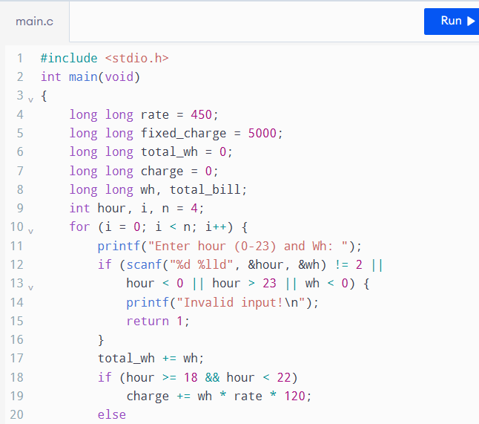
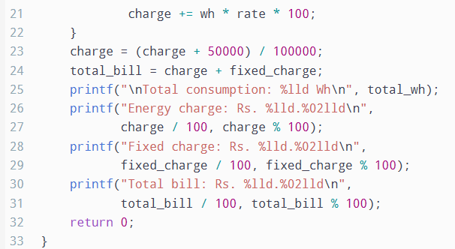
Output
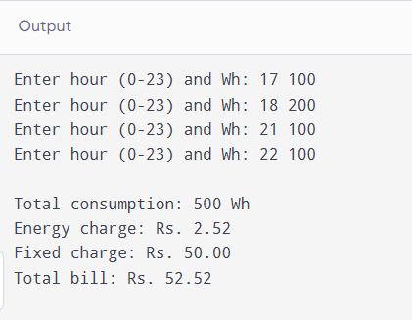
The file readings.txt must contain 35,040 lines, each containing the interval's hour (0–23) and energy consumed in watt-hours. The code assumes each record represents interval consumption, not a cumulative meter reading.

D. Evidence-Based Defence
The redesigned program is more suitable because it supports frequent readings, peak-hour pricing, and tariff changes without recompilation.Under the stated illustrative limit, the maximum yearly consumption is 2,296,346,400 Wh, which exceeds a signed 32-bit integer's range. A long long can store this amount comfortably.The program stores the accumulated charge in an integer representation and rounds only when converting the final charge to paise. This avoids repeated rounding at every interval. The tariff configuration can be updated without changing the C source code.However, the design still requires input validation, protection against arithmetic overflow, and testing with realistic maximum consumption. Its time complexity is O(n) for n readings, and its working storage is O(1) because readings are processed one at a time.

Conclusion / Result
The original design should be modified rather than retained unchanged. Wider integer types, runtime tariff configuration, and peak-hour calculations make the program more adaptable to smart meters. The revised design is suitable for district-scale processing when the input limits and accumulated arithmetic are validated.

